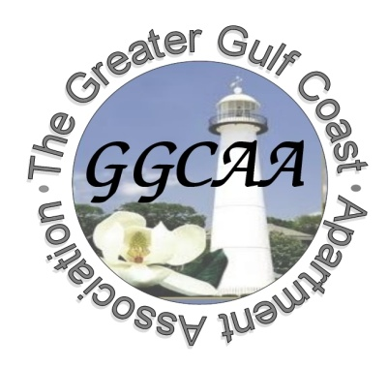
2019 The Greater Gulf Coast Apartment Association
Application For Membership
(One Application For Each Vendor/Management Company/Community)

Date: ______________________
Vendor, Management Company,
Owner, or Community Name: _______________________________________________________

If a Vendor, type of Services Offered By Your Company: _________________________________________________

Billing Address: ________________________________ City: _______________ State: _______ Zip: __________

Phone: (____) _____ - _______ Fax: (____) _____-________ Billing E-Mail: __________________________________

FOR EVENT AND NEWSLETTER CORRESPONDENCE (Include all email addresses for the Property/Company)

Representative or Contact Name: _______________________________ Email:_________________________________

Representative or Contact Name: _______________________________ Email:_________________________________

Representative or Contact Name: _______________________________ Email:_________________________________

Representative or Contact Name: _______________________________ Email:_________________________________

Apartment Community Information

Community Address:____________________________ City:________________State:_______ Phone: _____________

Community Contact Name: ____________________________________ Title: _________________________________

Community Main Email: ______________________________________ Number of Units:_____________________

Management Company Name: ___________________________________ Phone: _____________________________
DUES STRUCTURE FOR INDIVIDUAL APARTMENT COMMUNITIES
Dues Includes All National, State and Local Fees
DUES FOR VENDORS
Dues Includes All National, State and Local Fees

Total Number Of Units | Annual Dues
1 – 100 | $255 Year
101 – 150 | $295 Year
151 – 200 | $345 Year
201 – 250 | $385 Year
251 – 325 | $405 Year
326-499 Units | $465 Year
500 + | $515 Year
Total Dues | $350 Year

DUES FOR MANAGEMENT COMPANIES
Dues Includes All National, State and Local Fees

Total Dues | $350 Year

MAIL APPLICATION TO:

The Greater Gulf Coast Apartment Association P.O. Box 4747
Biloxi, MS 39535
**Please make checks out to GGCAA

Email Applications to:
ggcaa1@gmail.com

